**Image Dilation without using 'imdilate' function**

           In MATLAB, ‘imdilate’is the function that dilates the image using a structuring element. Let’s learn how this function works using some examples and codes.

[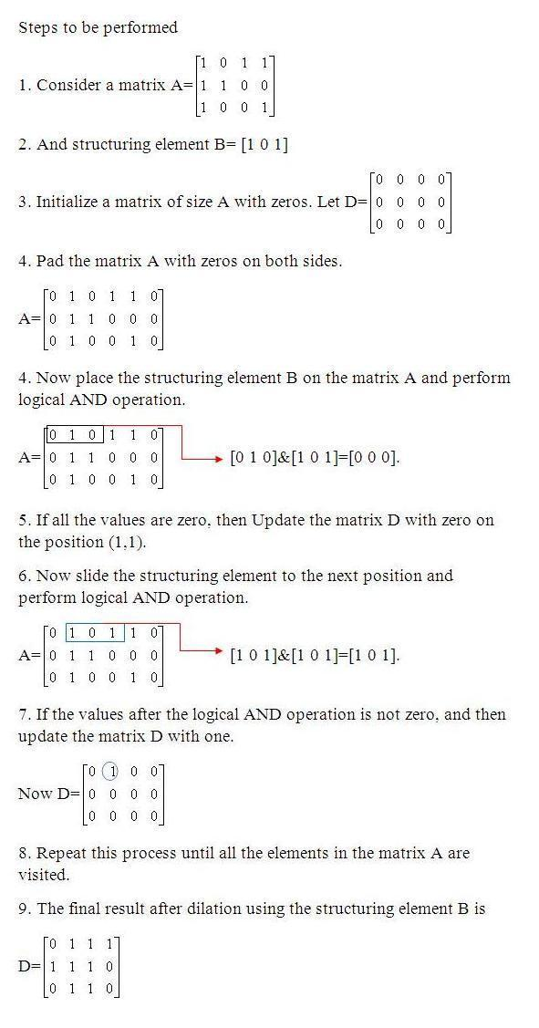](http://2.bp.blogspot.com/-N4E9LhhjIak/UFKoMWMSZoI/AAAAAAAAArY/bFzdOIFXDLQ/s1600/dilation_steps1.JPG)

MATLAB CODE[:](http://www.google.com/)

Example 1:

A=[1 0 0 0 1; 1 0 1 0 0; 1 1 1 0 0;0 0 1 1 1];

%Structuring element

B=[1 0 0; 0 1 0; 0 0 1];

%Pad zeros on all the sides

C=padarray(A,[1 1]);

%Intialize a matrix of matrix size A with zeros

D=false(size(A));

for i=1:size(C,1)-2

    for j=1:size(C,2)-2

        %Perform logical AND operation

        D(i,j)=sum(sum(B&C(i:i+2,j:j+2)));

    end

end

display(D);

[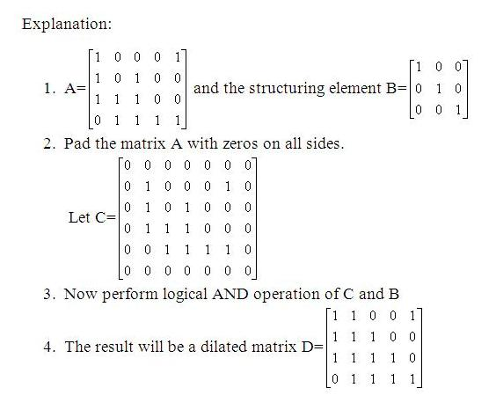](http://3.bp.blogspot.com/-0OsKiXlCwaE/UFIz1w6HCqI/AAAAAAAAAqs/UmqDcy5l9Sw/s1600/dilate_explanation.JPG)

Example 2:

A=imread('text.png');

|  |
| --- |
| <http://3.bp.blogspot.com/-F5fmwoGiKfE/UFI0MiBxHKI/AAAAAAAAAq0/LTAoHGFrUiQ/s1600/text_1.png> |
| Original Image |

A=im2bw(A);  
%Structuring element

B2=getnhood(strel('line',7,90));

m=floor(size(B2,1)/2);

n=floor(size(B2,2)/2);

%Pad array on all the sides

C=padarray(A,[m n]);

D=false(size(A));

for i=1:size(C,1)-(2*m)

    for j=1:size(C,2)-(2*n)

        Temp=C(i:i+(2*m),j:j+(2*n));

        D(i,j)=max(max(Temp&B2));

    end

end

figure,imshow(D);

|  |
| --- |
| <http://4.bp.blogspot.com/-gGNe-8OweEs/UFKotEZP54I/AAAAAAAAArg/wyoE1UZ6LXU/s1600/text_vertical.jpg> |
| Dilated Image |

Example 3:(Method 2)

A=imread('text.png');

A=im2bw(A);  
%Structuring element

B=[1 1 1 1 1 1 1;];  
C=padarray(A,[0 3]);

D=false(size(A));

for i=1:size(C,1)

    for j=1:size(C,2)-6

        D(i,j)=sum(B&C(i,j:j+6));

    end

end

figure,imshow(D);

|  |
| --- |
| <http://2.bp.blogspot.com/-wPSbvC-_zNU/UFKoyhk69kI/AAAAAAAAAro/ErjRKxIh2ak/s1600/text_horizontal.jpg> |
| Dilated image |